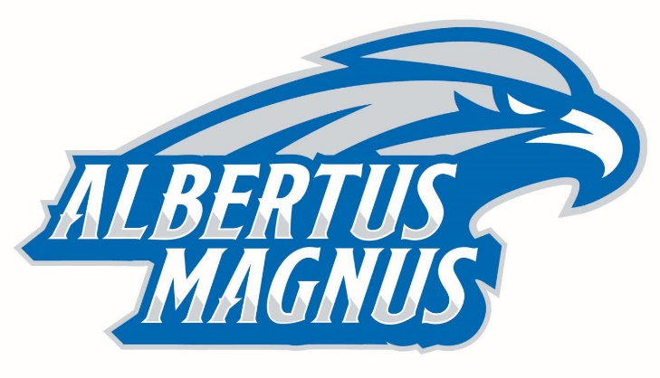
Concussion Awareness Letter
The Albertus Magnus College Athletic Training department would like to inform you that ___________________ sustained a concussion/head injury during the ________________ game on ____________. He/She was evaluated by the Albertus Magnus College Athletic Training staff and/or has been seen by a physician. Concussions range in significance from minor to major, but they all share a common factor – they temporarily interfere with the way the brain works. We would like to inform you that during the next few days/weeks this athlete may experience one or more of these signs and symptoms.
Headache Nausea
Balance Problems Dizziness
Diplopia – Double Vision Confusion
Photophobia – Light Sensitivity Difficulty Sleeping
Misophonia – Noise Sensitivity Blurred Vision
Feeling Sluggish or Groggy Memory Problems
Difficulty Concentrating

As a department, we wanted to make you aware of this injury and the related symptoms the student-athlete may experience. Although the student-athlete is attending class, please be aware that the side effects of the concussion may adversely impact his/her academic performance. Any considerations you may provide academically during this time will be greatly appreciated. We will continue to monitor the progress of this student-athlete and anticipate a full recovery. Should you have any further questions, please do not hesitate to contact us.

Ivo Wesseling, MAT, ATC, LAT
Director of Sports Performance and Athletic Traing
203-773-4472 or iwesseling@albertus.edu

